1. Defect 1: Ranking is incorrect: If the votes are same, the rank should be the same.

Actual Behaviour: Ranking is different for two models with same votes

Before voting

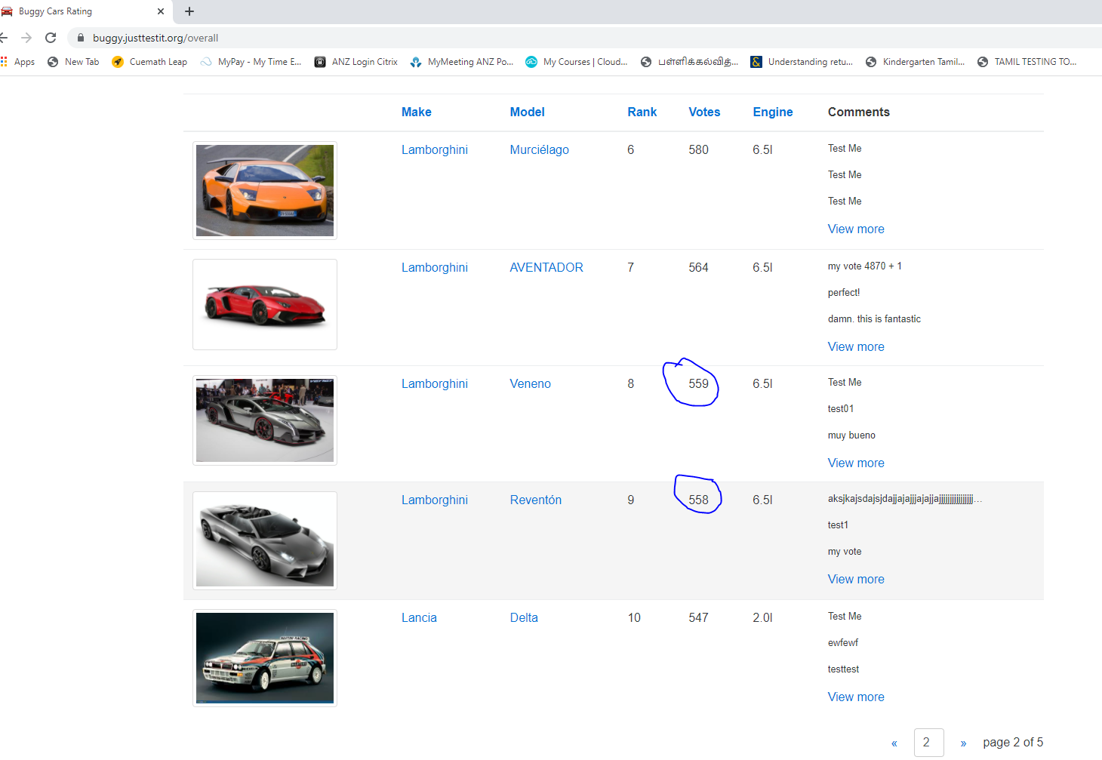

After voting

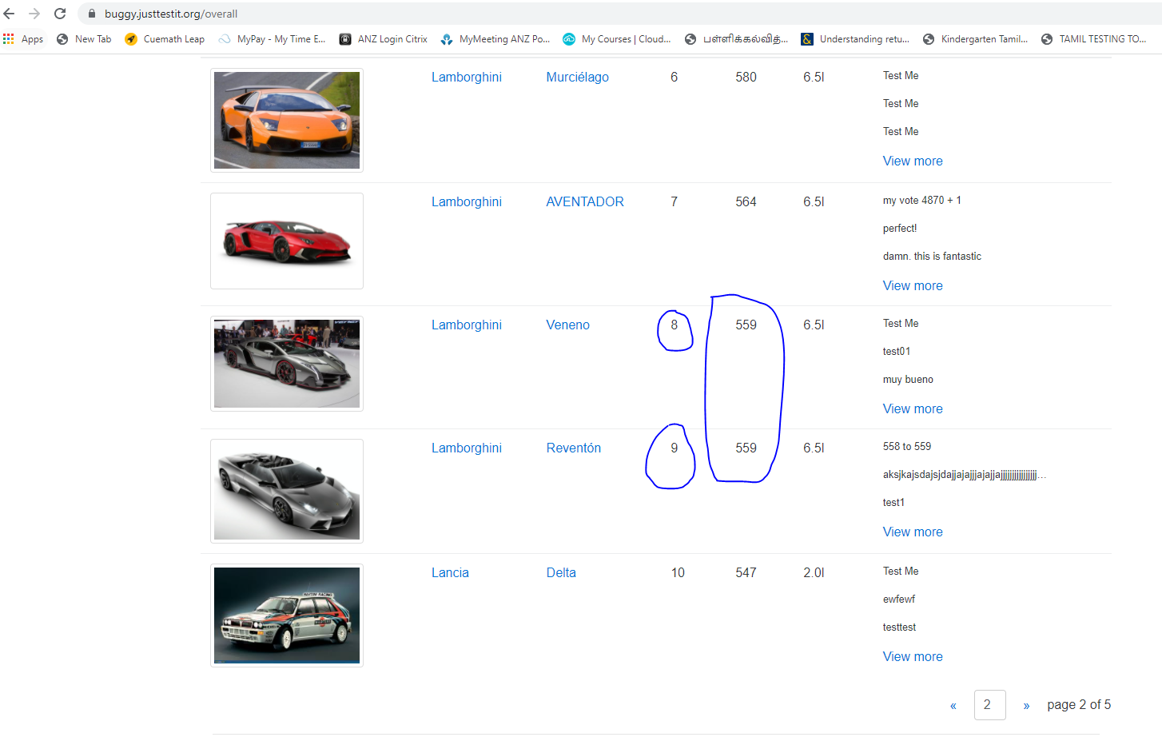

1. Author field is not getting populated after casting my vote on Diablo model and Lamborghini make

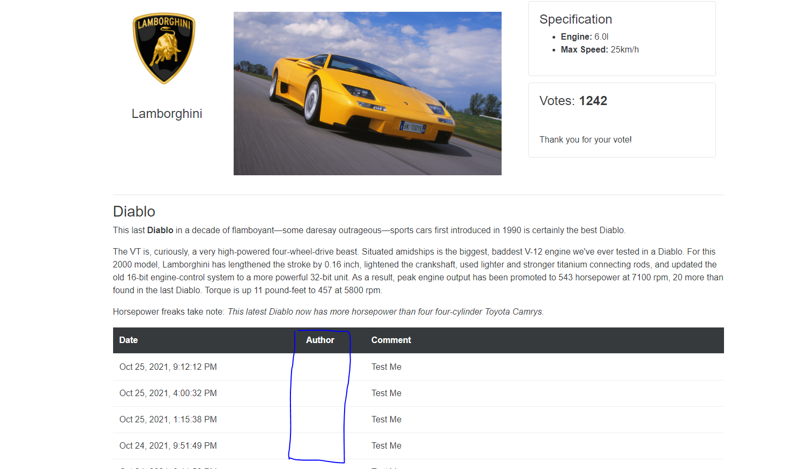

1. Broken Image for the Model Lancia Ypsilon

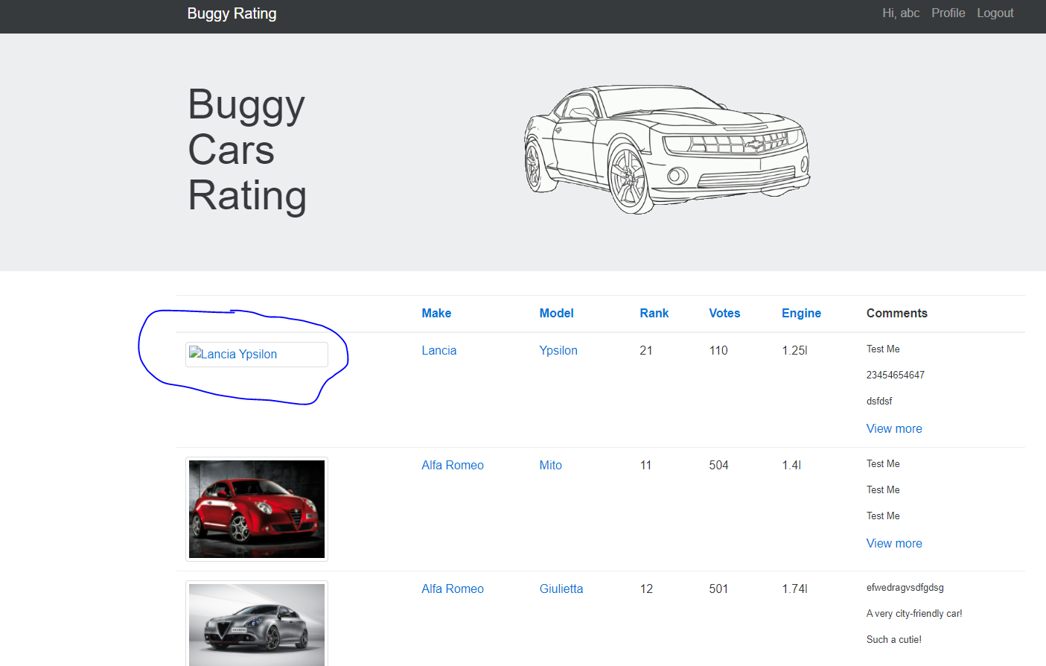

1. Log out does not work in Overall Rating Page:

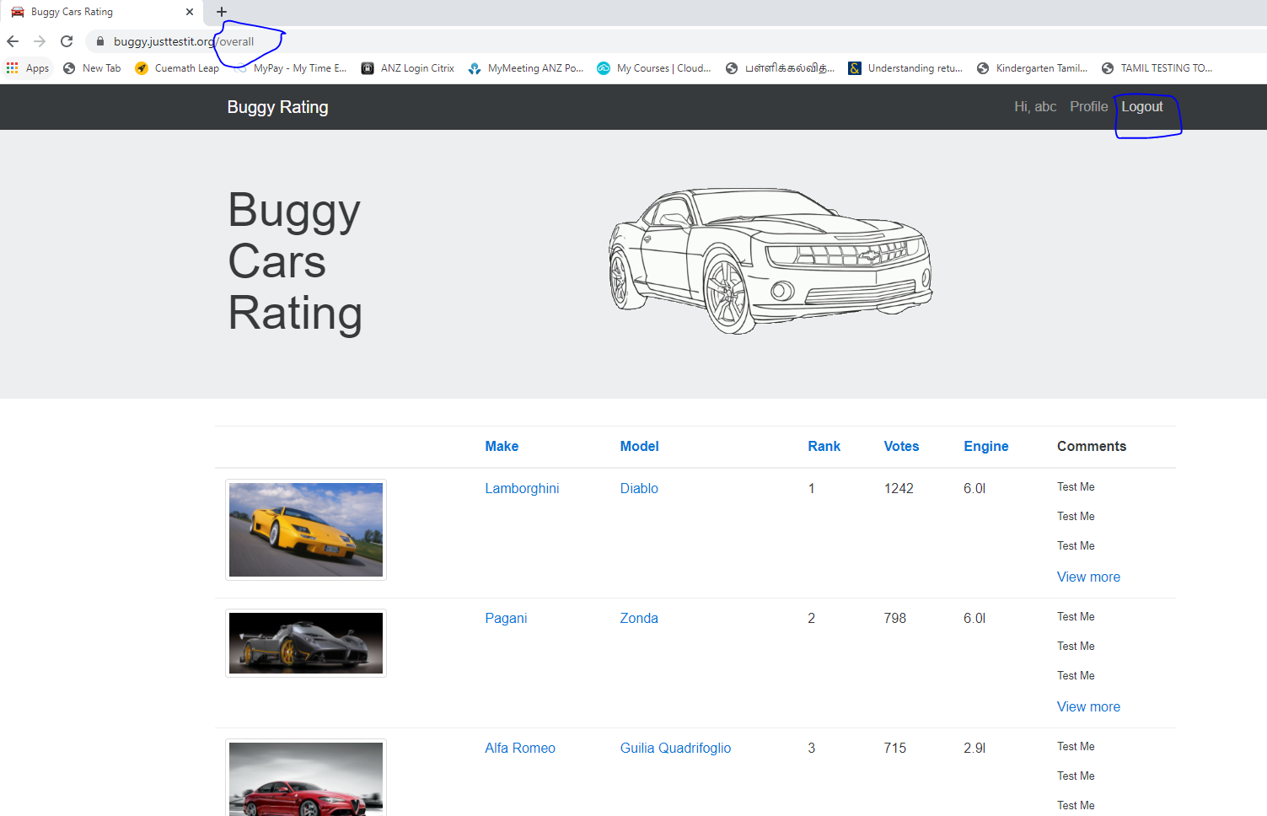

1. User is able to still see the Profile information even after logging out

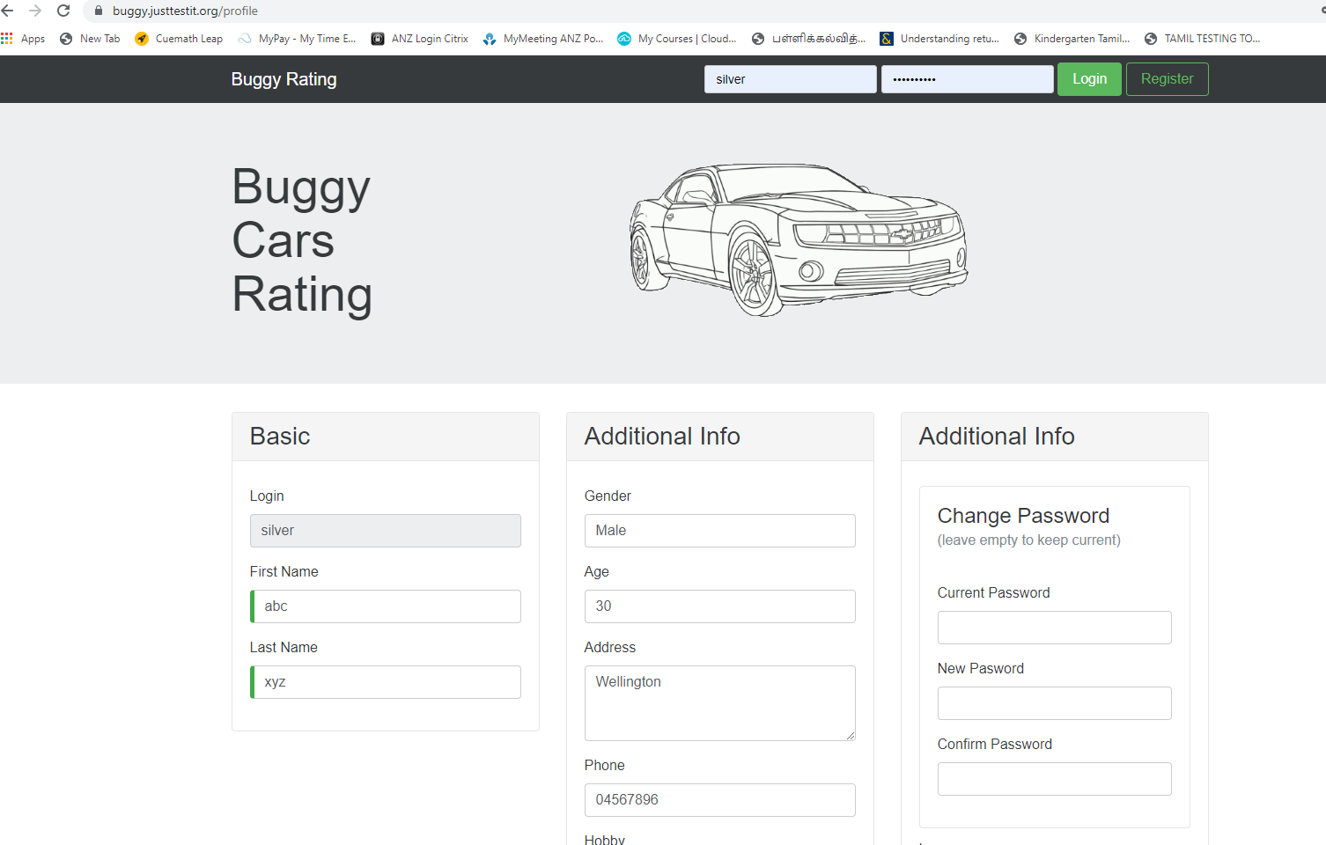

1. Login name during registration process should be case insensitive i.e., even though the user tries to register for the same username but change in the upper case or lower-case letters, the system should NOT allow – but currently its allowing to register same user name i.e., it is case sensitive currently. It needs to be case insensitive

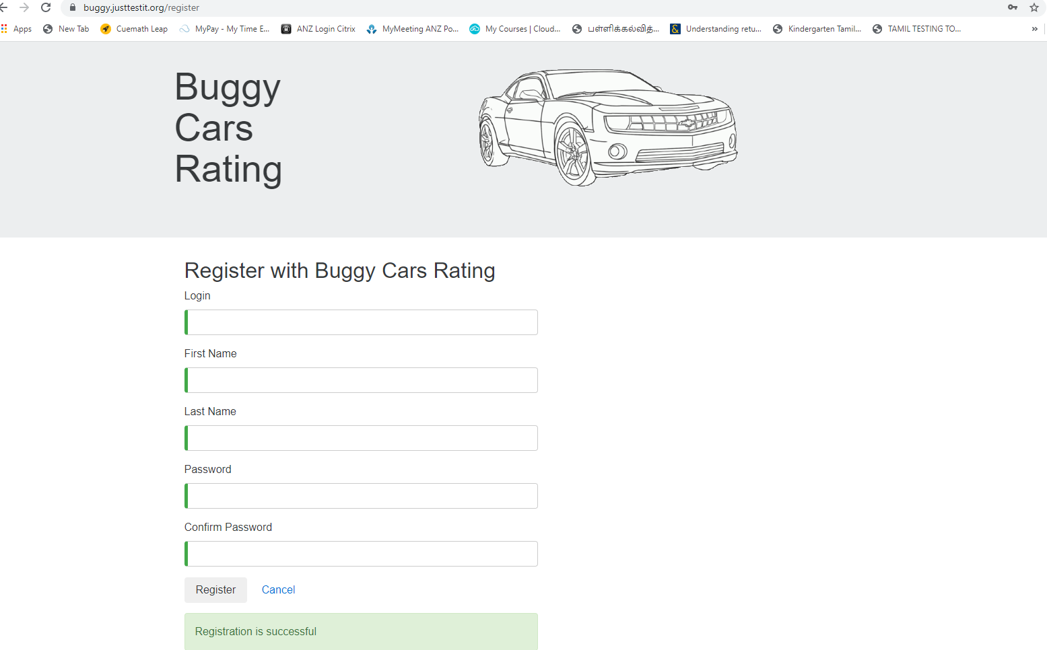

1. User is still able to register even after logged in: (This can be achieved by accessing the Register URL directly post login)

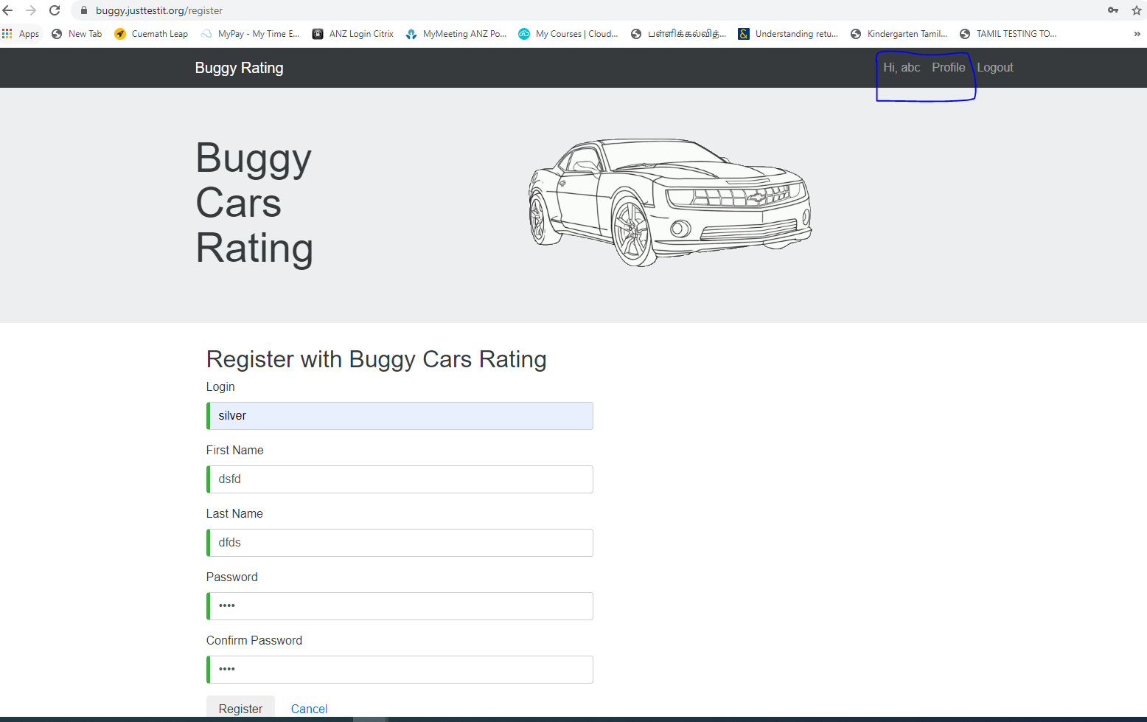

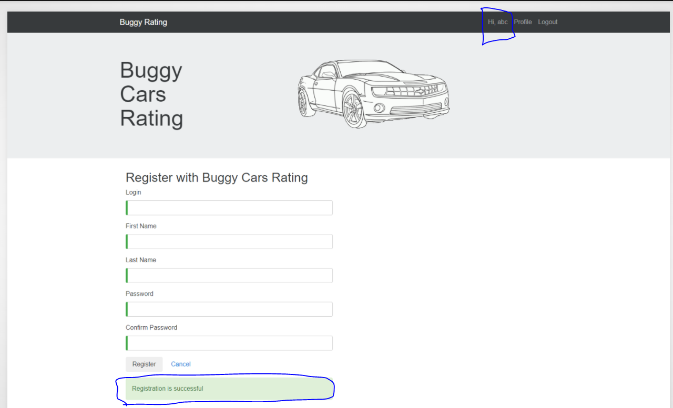

1. User is not able to navigate to home page i.e., broken link under Popular Make Page

